**Examples**

Base case, find--loe empty:



Base case, find—element:



* Failing right away

Other cases in find—element:



* Finding right away



* Not finding under the directory

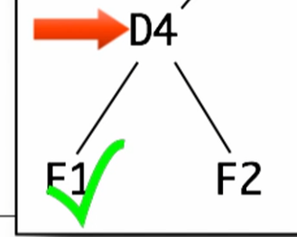



* First child of the directory

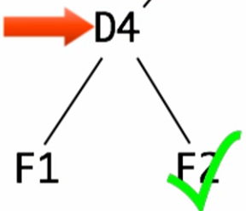



* Other child of D4

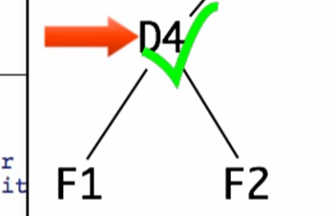



* This is just like finding right away but using directories

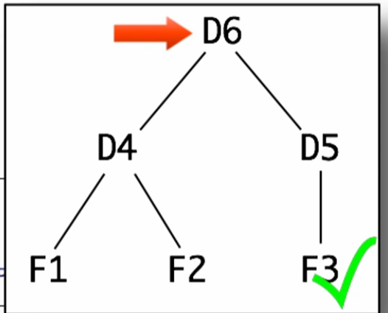



* Far right child of a directory

Run and check if well-formed

**Template**

Rename function, natural recursions, and mutual recursions

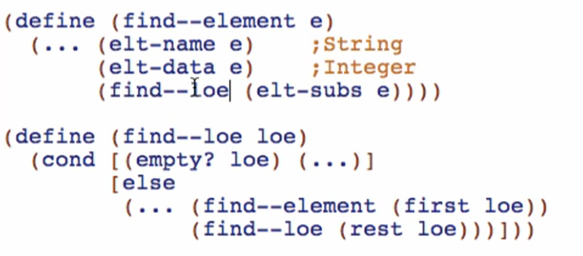

Then add the rule for the 2nd parameter

